Meshtastic Position Data Flow
How positions get from devices in the field to the Aervyx live tracking map.
Overview
There are 3 paths a position can take from the field to the live map:
Path | What sends the position | Internet needed on | Latency
1 - Phone Direct | Phone sends its own location over cellular | Pilot's phone | ~1s
2 - BLE Relay | Phone forwards mesh packets to Aervyx API | Pilot's phone | ~2-5s
3 - MQTT | Gateway node publishes to MQTT broker | WiFi/Ethernet gateway | ~5-15s

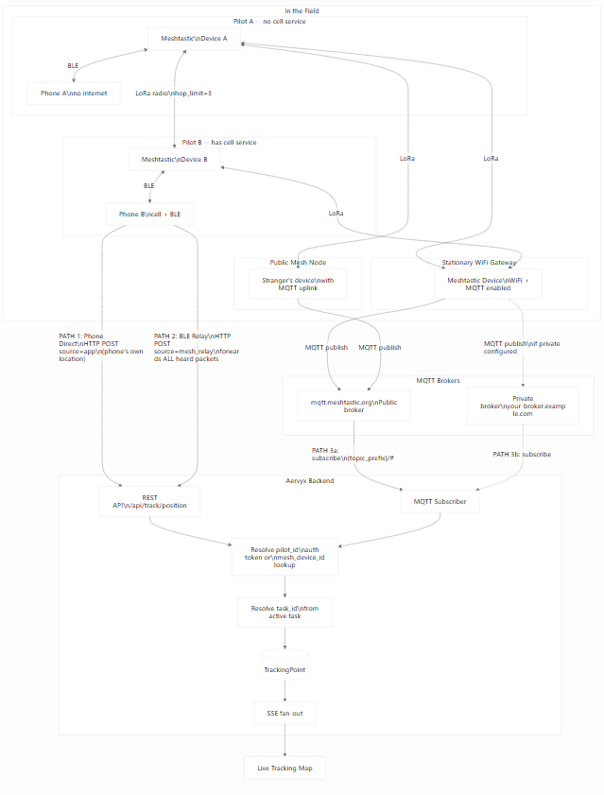

Path 1 -- Phone Direct (cellular)
The pilot's phone has cell service. The Aervyx mobile app sends the phone's own
location directly to the backend over cellular data. No Meshtastic device is
involved in this path -- it is pure phone-to-server.
Step | What happens
Phone location fix | Android/iOS location services provide lat/lon/alt
HTTP POST | POST /api/track/position with source=app
Auth | Bearer token identifies the pilot
Store + broadcast | Position saved, SSE pushed to live map
When it works: Pilot has cell service. Lowest latency, simplest path.
No mesh radio needed.

Path 2 -- BLE Relay (phone bridges mesh to API)
The phone is paired to a Meshtastic device via Bluetooth Low Energy. The device
receives LoRa packets from the entire mesh network. The phone app reads those
packets, parses the protobuf, and forwards every position to the backend.
Step | What happens
LoRa broadcast | Any mesh device broadcasts its position
Relay / rebroadcast | Other mesh nodes repeat the packet (up to hop_limit)
BLE delivery | Phone reads fromRadio BLE characteristic
Protobuf parse | App extracts MeshPacket -> Position (lat, lon, alt, speed)
HTTP POST | POST /api/track/position with source=mesh_relay, device_id=!XXXXXXXX
pilot_id lookup | Backend matches device_id to users.mesh_device_id
task_id lookup | Backend finds pilot's active task from event registration
Store + broadcast | Position saved, SSE pushed to live map
Key detail: This path forwards all mesh positions heard by the connected
device, not just its own. If Pilot B's phone has cell service and Pilot A is
beyond cell range but within LoRa range, Pilot A's position reaches Aervyx
through Pilot B's phone.

Path 3 -- MQTT (mesh to broker to Aervyx subscriber)
A Meshtastic device with internet access (WiFi or Ethernet) and MQTT enabled
acts as a gateway. It publishes every mesh packet it receives to an MQTT broker.
The Aervyx backend subscribes to that broker.
Step | What happens
LoRa broadcast | Device broadcasts position via radio
Mesh relay | Other nodes rebroadcast (up to hop_limit)
Gateway receives | Any MQTT-enabled node with internet hears the packet
MQTT publish | Gateway publishes to broker topic msh/US/2/e/LongFast/!GATEWAYID
Decode/decrypt | Plaintext packets are parsed directly; encrypted packets are decrypted with the configured/default channel PSK when possible
Aervyx subscribes | MQTT subscriber receives the ServiceEnvelope message
Protobuf parse | ServiceEnvelope -> MeshPacket -> Position
pilot_id lookup | from_node -> !XXXXXXXX -> users.mesh_device_id
task_id lookup | Active task resolution from event registration
Store + broadcast | Position saved, SSE pushed to live map
Gateway topic rule: On the public broker, Aervyx subscribes to registered mesh
device IDs. If an Ethernet/Wi-Fi gateway is publishing packets heard from trackers,
the gateway ID must be registered too; trackers appear inside the MeshPacket from
field, not necessarily in the MQTT topic suffix.
MQTT encryption: Our profiles set encryption_enabled=false on the MQTT config
so that channel packets arrive in plaintext on the broker. If a device publishes an
encrypted MeshPacket anyway, the backend records it as heard and attempts
Meshtastic AES-CTR decryption with the configured/default channel PSK. Wrong or
missing keys still prove the gateway/sender were heard, but no position is stored.

Public vs Private MQTT
Public broker (mqtt.meshtastic.org)
Your devices --> mesh --> ANY node with MQTT uplink --> broker
(yours OR a stranger's)
- Broader coverage: random hikers, other pilots, and public gateways all relay
your positions for free
- Zero infrastructure: Meshtastic runs the broker
- Your positions are visible to anyone subscribing to the public broker
- You share bandwidth with all Meshtastic traffic worldwide
Private broker (self-hosted)
Your devices --> mesh --> only YOUR configured nodes --> your broker
- Private: only you see the data
- Dedicated bandwidth, no shared noise
- No benefit from public nodes -- strangers cannot relay to your broker because
they do not have your credentials
- You must run and maintain the broker infrastructure

Radio relay vs MQTT uplink
These are two different things:
- Radio relay happens at the LoRa level. Every Meshtastic device in range
rebroadcasts packets it hears, up to hop_limit. No internet, no decryption,
no channel matching needed. A stranger's device on a mountaintop extends your
mesh range automatically.
- MQTT uplink happens at the application level. A device with internet +
channel uplink enabled forwards channel traffic to an MQTT broker. This is how
positions reach the Aervyx backend via Path 3.
A stranger's device always helps with radio relay. It only helps with MQTT uplink
if it is on the same channel with uplink enabled and connected to the same broker.

Scenario: Pilot A is out of cell range
Pilot A (no cell) Pilot B (has cell) Aervyx

| | |
| -- LoRa broadcast ----> | |
| (position packet) | |
| | |
| Phone receives |
| packet via BLE |
| from Device B |
| | |
| | -- HTTP POST --------> |
| | source=mesh_relay |
| | device_id=!A_ID |
| | |
| | Resolve:
| | !A_ID -> Pilot A
| | Pilot A -> active task
| | |
| | Store + SSE broadcast
| | |
| | Pilot A appears
| | on live map
Pilot A never had internet, but their position reached the map through the mesh
network and Pilot B's phone acting as a relay.

Device ID auto-registration
When a pilot connects to a Meshtastic device via BLE in the mobile app, the app
automatically registers that device's node ID (!XXXXXXXX) against the pilot's
account. No manual configuration is needed.
If the pilot switches to a different device, the new device ID overwrites the
old one. This means the MQTT subscriber and BLE relay can always resolve
incoming mesh positions to the correct pilot.
Infrastructure devices (Repeater profile) are a special case: when a user applies
the Repeater profile, the app unregisters the device from their account. This
prevents a stationary relay node from being tracked as a pilot. When the same
phone later connects to a personal tracker, the new device is auto-registered
normally.
DatabaseAervyx APIMeshtastic DeviceMobile AppDatabaseAervyx APIMeshtastic DeviceMobile AppFuture mesh positions from !abcd1234now resolve to this pilotBLE connectConfig dump (includes myNodeNum)Format node ID: !XXXXXXXXPUT /api/auth/mesh-device{"mesh_device_id": "!abcd1234"}UPDATE users SET mesh_device_id = '!abcd1234'WHERE id = current_user.id200 OK

Live tracking works for everyone
Positions are stored and broadcast regardless of whether the pilot is in an
active competition task. The live tracking map has three viewing modes:
Mode | What it shows | SSE endpoint
Task | Pilots in a specific competition task | /api/track/live/{taskId}
Buddy group | Selected pilot IDs | /api/track/live/pilots?ids=...
All users | Every active position (public) | /api/public/live/all
A pilot flying free (no active task) still appears in "All users" and buddy
group views. The task_id is optional -- it enables the task-scoped competition
view but is not required for tracking to work.

Requirements for each path
Requirement | Path 1 (Phone Direct) | Path 2 (BLE Relay) | Path 3 (MQTT)
Meshtastic device needed | No | Yes (paired via BLE) | Yes (any node with MQTT)
Phone has cell service | Yes | Yes | No
MQTT gateway node exists | No | No | Yes
Device auto-registered to user | No | Yes (auto on connect) | Yes (auto on connect)
Pilot registered for active task | No | No | No
What provides internet | Phone cellular | Phone cellular | Gateway WiFi/Ethernet

